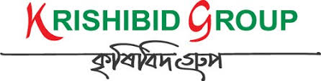

KG Work Management

USER MANUAL

**Prepared by: IT Department, Krishibid Group**

Content

Introduction 2

Description of the Work Management System 2

Six key elements for better Work Management 3

1. Dashboard 4

**1.1 ERP Login Page** 4

**1.2 ERP Home Page** 5

2. Work Management 5

**2.1 Task Status** 5

**2.2 Task List** 6

**2.3 Task Overview** 7

**2.4 Member Task List** 7

# Introduction

The Krishibid Group has initiated development of Enterprise Resource Planning (ERP) with the essence of establishing an effective database, to address and strengthen existing information system through coordinating and networking of existing human resource data collection systems. Krishibid consulted a team of experts, department of IT of Krishibid Group to take the responsibility of developing, implementing and maintaining HRMS system in this organization. **As for any big system development the process is not an overnight thing.** **Work Management** **System** is evolving, though with a remarkable speed, the inputs of stakeholders are all time required.

This manual outlines the systematic procedures for accessing and using one of the most important parts of the KG ERP system. In case you do not get the assistance, you expected from the manual please consult your system administrator or any person authorized to work as the member of the helpdesk team at your organization.

# Description of the Work Management System

**Work Management** is the process of managing a task through its life cycle. It involves planning, testing, tracking, and reporting. Task management can help either individual achieve goals, or groups of individuals collaborate and share knowledge for the accomplishment of collective goals. Tasks are also differentiated by complexity, from low to high. Work management may form part of project management and process management and can serve as the foundation for efficient workflow in an organization. Project managers adhering to task-oriented management have a detailed and up-to-date project schedule, and are usually good at directing team members and moving the project forward.

Effective task management requires managing all aspects of a task, including its status, priority, time, human and financial resources assignments, recurrence, dependency, notifications and so on. These can be lumped together broadly into the basic activities of task management.

Managing multiple individuals or team tasks may be assisted by specialized software, for example workflow or project management software. In fact, many peoplebelieve that task management should serve as a foundation for project management activities.

Be the Management, applesauce. Managers are the people in charge of employees and the facilities they work for. As a manager, to plan and promote the daily schedule of employees and the business and coordinate employees, create and maintain budgets, and coordinate with and report to senior management in the Krishibid Group. Managers can have one employee directly reporting them, or hundreds, depending on the job and work volume. Ultimately putting Task Management in place gives organizations the tools and information necessary to collaborate and manage their workload as a team.

# Six key elements for better Work Management

* **Classify** -- Define the type of work: New Feature, Action Item, Defect, etc. It helps everyone understand what needs to be done.
* **Target** -- Target tasks to your plans' milestones. Measuring progress is easier with metrics when remaining tasks and issues can be related back to the plan, keeping team members focused and working toward a common goal.
* **Prioritize** -- All team members should understand the priority system. Practice priority diversity: if priority 1 is critical and 3 the least critical, it makes no sense to make all tasks priority 1.
* **Collaborate** -- Get the right tasks assigned to the right people. Make sure that ownership is clear and reasonable. Workloads have to be balanced and fair and it should be easy for people to get the help they need from other team members.
* **Check Status** -- Regularly track task status. It should be easy to see what is completed, what remains to be completed, and what issues exist. It is never a good idea to spend hours with managers and team members to get this information.
* **Track Compliance** -- Keep a complete work history for each task. This is a good idea for many reasons. It helps you understand what issues remain, how to improve your plans, understand and correct process issues, and comply with appropriate industry standards

# 1. Dashboard

## **1.1 ERP Login Page**

Open the browser and type the following address: http:// [http://192.168.0.7:90](http://192.168.0.7:90/) then a page similar to the one shown in the image below will be displayed whereby a user will be required to type in their correct **username** and **password**. This system works best with Google Chrome, Mozilla Firefox, Microsoft Edge or Opera browsers. From here on, the use of the word “browser” will refer to above mentioned web browsers only.

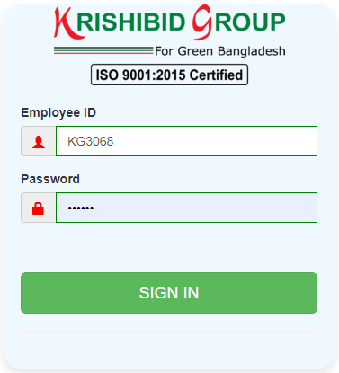

**Figure: 01 ERP Login**

**Logging on ERP System:**

* **Step-1:** Provide Valid **Username and Password. For Username Always Provide your Employee ID. (Example: EmployeeId: KGXXXX, Password: KGXXXX) with UPPERCASE.**
* **Step-2:** Click on **‘Sign In’** button for go to Home page of ERP.

## **1.2 ERP Home Page**

On successful login, a user is directed to the Home Page which consists of the main menu on the left side named dashboard. At the top most part of the system you will have on your left a home icon to denote the home page, a help button- which contains this help manual and the Employee Id of the user currently accessing the system.

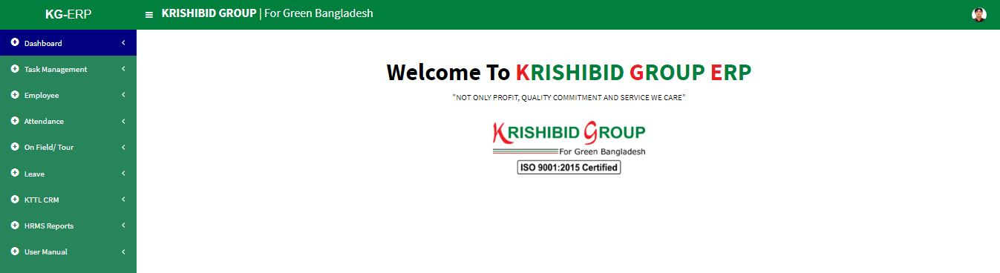The following figure (Fig-02) shows menu bar and home page.

**Figure: 02 ERP Home Page**

* **Step-01:** Click on the Dashboard section under main navigation panel of KG ERP.

# 2. Work Management

## **2.1 Task Status**

**Figure: 03 Task Status**

* Click on the **Task Status** section under **Task Management** option. The following figure (Fig-03) shows the Status information based on all necessary status for any work.
* **Step-01:** Click on **Add** Button for adding new Task Status. Enter **‘State’, ‘Remarks’ and check Active** button then click on **Create** button for save any new Task State.
* 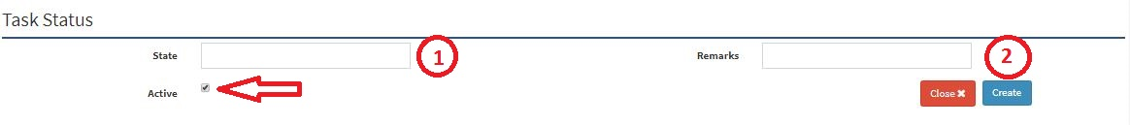**Step-02:** Click on Edit Button or Delete Button. User can **Update** or **Delete** any state which one is not dependent any Assign task.

**Figure: 04 Task Status Entry Page**

## **2.2 Task List**

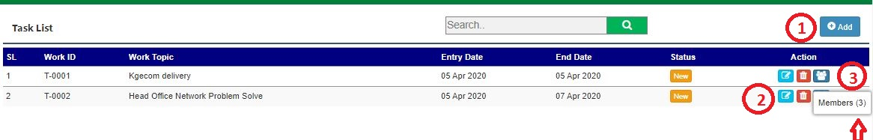

**Figure: 05 Task List**

* Click on the **Task List** section under **Task Management** Menu option.
* **Step-01:** Enter **“Work ID”, “Work Topic”,** “**Entry Date”, “End Date” and “Status”** forthe search any Task based on priority and click “**Add**” button for adding new task under multiple employee. Enter ‘Work Topic’, ‘Work Detail’, ‘Remarks’, ‘Entry Date’, ’Expected End Date’, ‘End Date’, ‘Status’ and checked on Active button then Click on Save button to add new Task for employee. (Fig: 06)
* **Step-02:** Click on Edit or Delete Button. Line Manager can **Update** or **Delete** any work topic or date which one is not dependent any Assign task.
* **Step-03:** Click on Assign Button. Line Manager can **Assign** any Work Topic for multiple Employee. Line manager can see total Assigned member of any task. Just to swap mouse cursor on the Assign button.

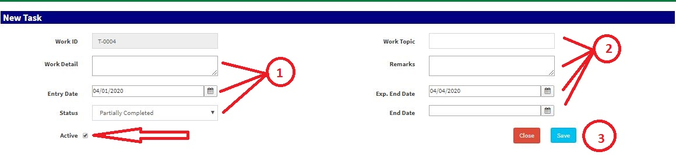

**Figure: 06 Task Entry Page**

## **2.3 Task Overview**

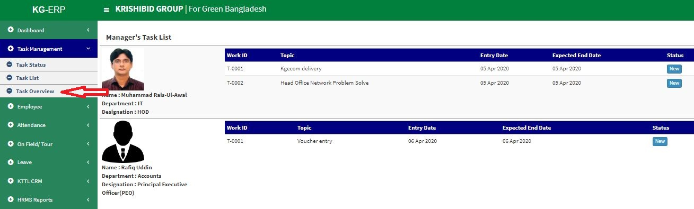

**Figure: 07 Task Overview Page**

* Click on the **Task Overview** section under **Task Management** Menu option.
* Management can view only to KG all Manager’s Task update summery.

## **2.4 Member Task List**

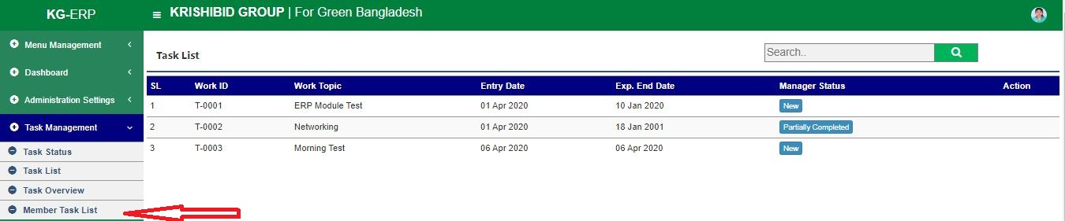

**Figure: 08 Member Task List Page**

* Click on the **Member Task List** section under **Task Management** Menu option.
* Responsible member can view their individual Task list summery.